Worksheet 6

Name :- Rahul maurya UID :- 20BCS7260

Class :- cse 716b subject mpi lab

Aim

Shifting operators on 8 bit

Code:-

#BEGIN5000 H

LDA 2500

RAL

STA 2501

HLT

#ORG 2500

#DB 36

Code 2nd:-

#BEGIN5000 H

LDA 2500

RAL

RAL

STA 2501

HLT

#ORG 2500

#DB 36

Output :-

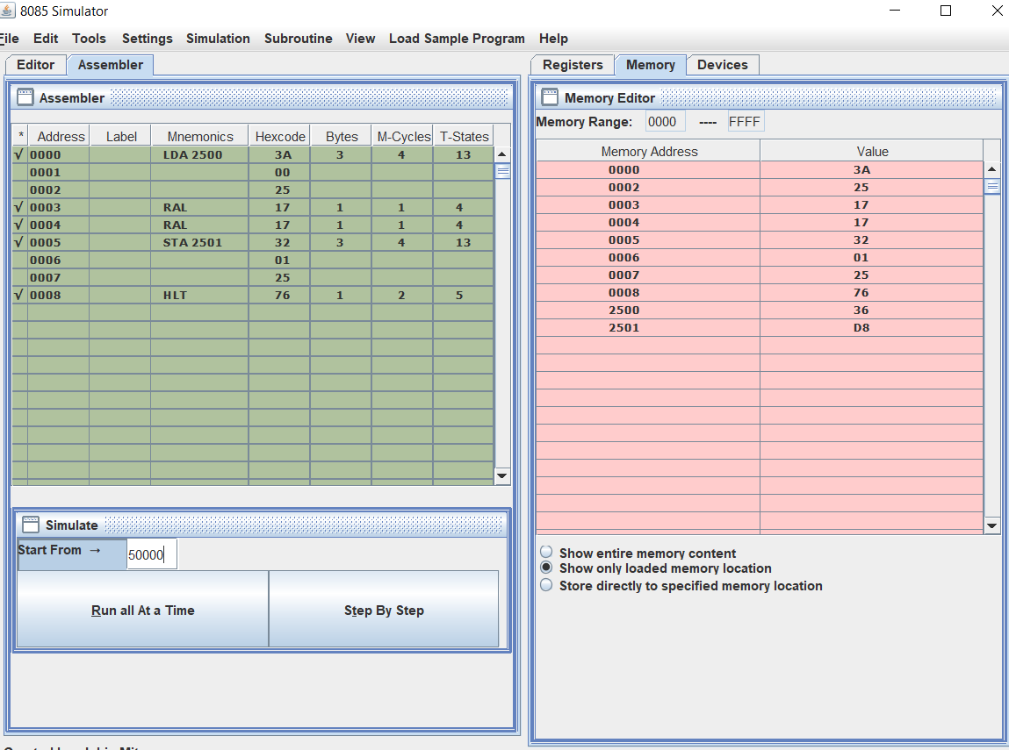L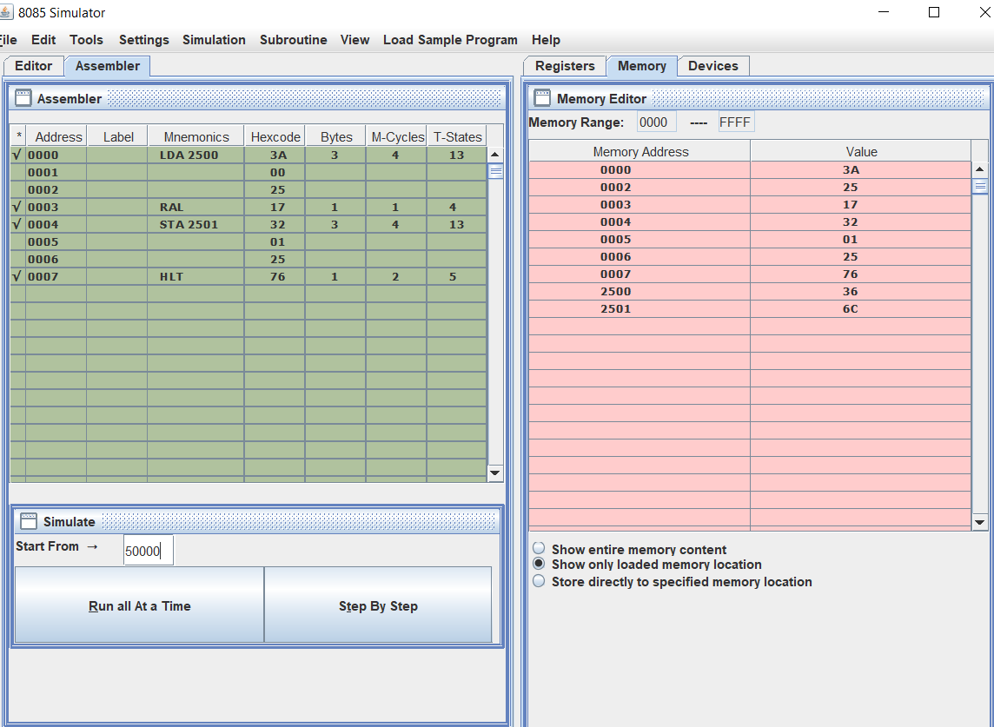earning outcomes :-

1 learnt about shifting operators

2 I learnt about adding and double shifting operators